Community Conversations
A series of discussions on key issues
in our region and the world, hosted by

St. Brendan the Navigator Episcopal Church

On Restorative Justice with Volunteers for Hancock County Jail Residents, featuring Jim Bergin, Judy Garvey, Jean Hendrick, and Carolyn Mor
Sunday, June 9th, 11:30 AM
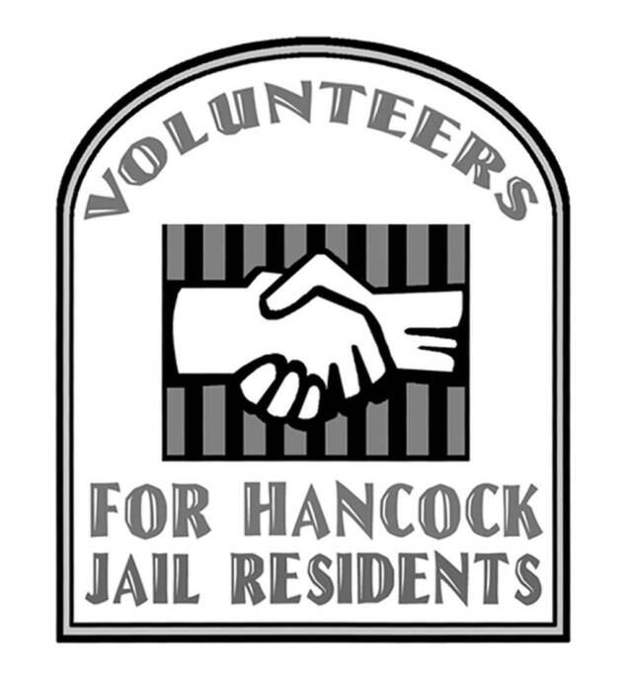
Volunteers for Hancock Jail Residents (VHJR) is dedicated to building bridges between Hancock County jail residents and the larger community. VHJR volunteers provide restorative assistance to help citizens find positive roles after they serve their sentences and return home. jailvolunteers.org

The Restorative Justice Project of mid-coast Maine promotes fundamental change in the justice system and schools with responses to crime and wrongdoing that promote renewal and safety for the community, support and healing for victims, and accountability and reintegration of the offender. www.rjpmidcoast.org/

On Homelessness and Poverty with Tracey Hair, executive director, H.O.M.E.
Sunday, June 23rd, 11:30AM

H.O.M.E. Inc. is a not-for-profit organization dedicated to enhancing the quality of life for low-income and homeless families. H.O.M.E fosters possibilities for food, jobs, shelter, education, and self-sufficiency. It oversees shelters in our area where those in need may also work or provide service for the wellbeing of others. H.O.M.E. staff and volunteers create a nurturing community where formerly homeless residents, current homeless shelter residents, and other low-income people are engaged in all levels of program administration. Everyone has a seat at the table. www.homemmausa.org

